# Report summary for Total (CD8+/-) Vb3+ % Viable for samples with different cell number and different holding time of antibody cocktail prior to staining

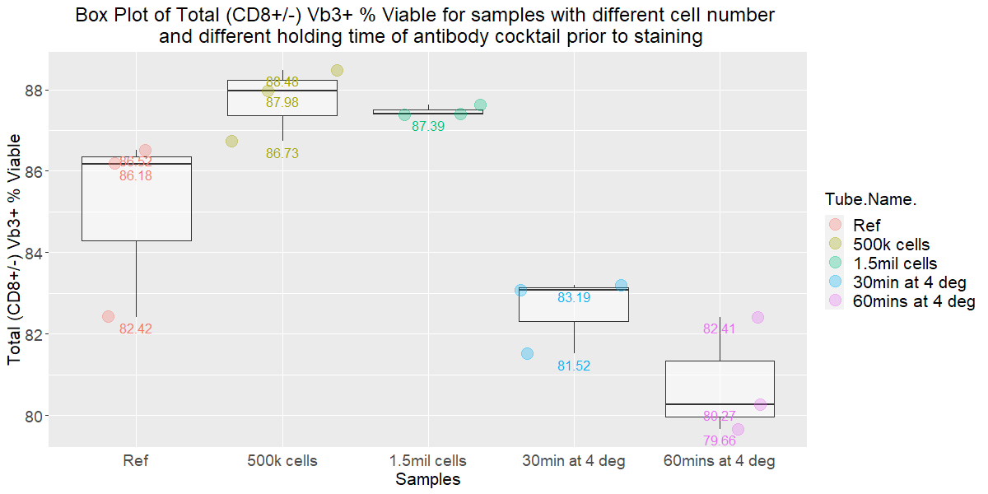

Anova results

Performing an ANOVA shows that one of the groups exhibits a significant difference in their mean.

Post-hoc analysis using least Square Means with Tukey’s adjustment

P-values for Ref-500k cells, Ref-1.5mil cells, Ref-30mins at 4 deg, and Ref-60mins at 4 deg are each greater than 0.05, so there is no significant difference in their means.

# Report summary for Total (CD8+/-) Vb3+ % Viable for samples with different antibody and DraQ7 staining time

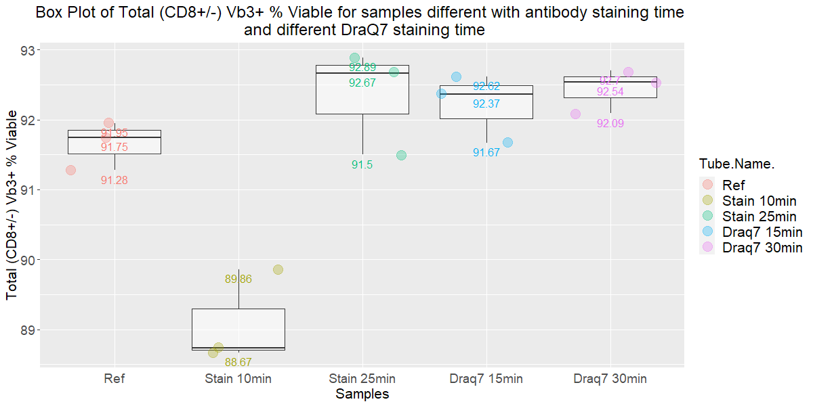Anova results

Performing an ANOVA shows that one of the groups exhibits a significant difference in their mean.

Post-hoc analysis using least Square Means with Tukey’s adjustment

P-values for Ref-Stain 25min, Ref-DraQ7 15min, Ref-DraQ7 30min are each greater than 0.05, thus there is no significant difference in their means. However, for Ref-Stain 10min, the P-value is less than 0.05 (P-value = 0.0012 < 0.05), thus there is a significant difference in the means between the Reference group and the group that is stain with the antibody cocktail for 10 minutes.